**Business Communications**

**Communication:** It is the process of passing information and ideas from one person to another. In simple words it is a process of transmitting and sharing ideas, opinions, facts, values etc. from sender to another or receiver.

**Why Communication:** The significance of communication is to communicate with other people. Communication thus helps understand people better to clear their misunderstanding and creating clarity of thoughts and expression. It also educates people. The communication may be written or oral, formal, or informal. It also helps us to understand others better, express ourselves, grow & prosper, socialize.

**Who are the best Orators?**

Best orators are the people who have the best communication skills. They are the one who raise excellent points, making everyone in the audience want to join their revolution. Generally they are the leaders of their respective fields.Some of the best orators are Narendra Modi, Barrack Obama, Netaji Bose, Oprah and many others.

**Let’s Draw: Bug Activity**

In this activity we were required to draw a bug. This was important in this activity we were asked to listen to the details of the bug which were communicated to us by our mentor and we were required to draw it exactly as described. At last we compared our drawing with that of our mentors drawing. The comparison helped us to know about our listening skills.

**Communication is omnipresent**

Communication is omnipresent because in real life communication is present every-where. From humans to animals and birds every living things communicate with each other. In this discussion we did a small funny activity where we formed groups and we made various animal noises.

**Components of Communication**

There are basically 3 components of communication that are **sender, channel & receiver.**

**RECEIVER**

**CHANNEL**

**SENDER**

**Sender -** Sender is a person who sends the message. A sender makes use of symbols (words or graphic or visual aids) to convey the message and produce the required response. Sender may be an individual or a group or an organization. The verbal and non-verbal symbols chosen are essential in ascertaining interpretation of the message by the recipient in the same terms as intended by the sender.

**Channel** - Channel is a means used to exchange / transmit the message. The sender must choose an appropriate medium for transmitting the message else the message might not be conveyed to the desired recipients. The choice of appropriate medium of communication is essential for making the message effective and correctly interpreted by the recipient. This choice of communication medium varies depending upon the features of communication. For instance - Written medium is chosen when a message has to be conveyed to a small group of people, while an oral medium is chosen when spontaneous feedback is required from the recipient as misunderstandings are cleared then and there.

**Receiver** - Receiver is a person for whom the message is intended. The degree to which the decoder understands the message is dependent upon various factors such as knowledge of recipient, their responsiveness to the message, and the reliance of receiver.

**Mode of Communication:**

The various modes of communication are:

* Posters
* Email
* Telephone
* Letters
* Memos
* Handbook
* Events
* Videos
* Grapevines(Gossips)

**Major Communication Media:**

1. **Data/Email:** Everyday a huge amount of data is transferred all around the world. This data varies from emails to various kinds of documents like Microsoft documents.

**Advantages –**

* It is eco-friendly and fastest way of communication
* It is the best form of non-verbal communication
* Data/Information can be easily sent to large group of people at once.
* The information which is sent is well encrypted and secured properly.

**Disadvantages –**

* Immediate response is not guaranteed.
* If there are lots of mails then there are chances that important ones will be missed.
* There is a risk of phishing attacks which can compromise our account.
* Emails require internet to be accessed.

1. **Voice:** Voice can be formal or informal talk to another person via mediums like face to face, telephonic or via video calls.

**Advantages –**

* **It is the best means of communication**
* Easy to explain as immediate feedback is required.
* Can convey emotion effectively
* Suitable for mass communication

1. **Video:**

**Disadvantages-**

* Immediate response is not guaranteed.
* There can be difference in time zones.
* Proper Internet Access is required
* Training required to carry the video call with proper body language.
* **Advantages-**
* Useful for mass communication
* It can be played again and again
* Non-verbal communication can be carried out.
* Videos are retained in memory for longer time.
* It is most interesting mode of communication.

IN THE OTHER PART DIFFERENT SITUATIONS WERE GIVEN TO US SO THAT WE CAN DEAL WITH REAL LIFE SITUATIONS

SITUATION 1:

**The server is going to be down after 5pm you are admin. How will you communicate this to all the employees in your organization**

Either I will convey it to higher authorities or try to send a bulk email to all the employees regarding the difficulty.

SITUATION 2:

**You need to invite your friends to sister´s wedding. how will you send out the invites to your friends, relatives and colleagues?**

For close friends- an informal call or message.

For relatives and colleagues - invitation cards in formal way.

SITUATION 3

**Your parents have seen a girl/boy for you and have seen everything about him/her.so how will you take this forward? What will be your reaction?**

I would like to meet the girl first and know her myself and then I will take further decisions.

**OBSERVATIONS AND LEARNING**

Face to face communication is the most convenient way of communicating but it all depends on situation.

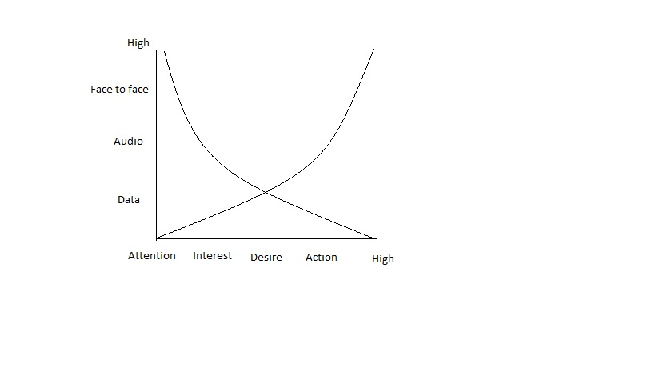

**MOST EFFECTIVE WAY OF COMMUNICATION**

Face to Face

VIDEO

AUDIO

DATA

**MEDIA**

**FACE TO FACE CONVERSATIONS**

ADVANTGES:

* In face to face conversation we can explain everything clearly.
* Give immediate feedbacks
* Demonstration and other things can be taken and given at the same time.

DISADVANTAGES:

* Denying or refusal becomes difficult
* Sometimes we leak extra information
* We tend to indulge in long discussions while having face to face conversations.